**Pick optimal number of parameters for unsupervised learning :**

**→ AIC/BIC as a guide to pick the number of parameters in a model .**

**→ When we are trying to fit something to our model so how we know that which number of clusters it’s want like two clusters or three clusters .**

**→ In the images it is easy to find clusters.**

**→ AIC means A Key Information Criteria .**

**→ BIC means Be Easy Information Criteria .**

**→ This two criteria is very helpful to find number of parameters .**

**(1) Read our image and reshape it .**

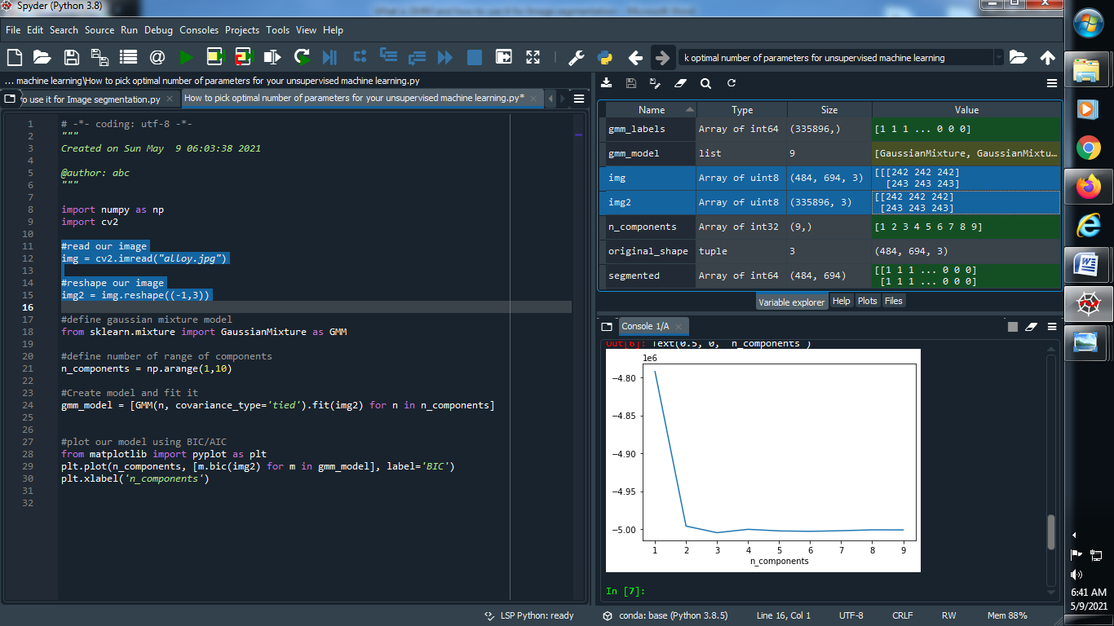

**Output :**



**(2) Define Gaussian model :**

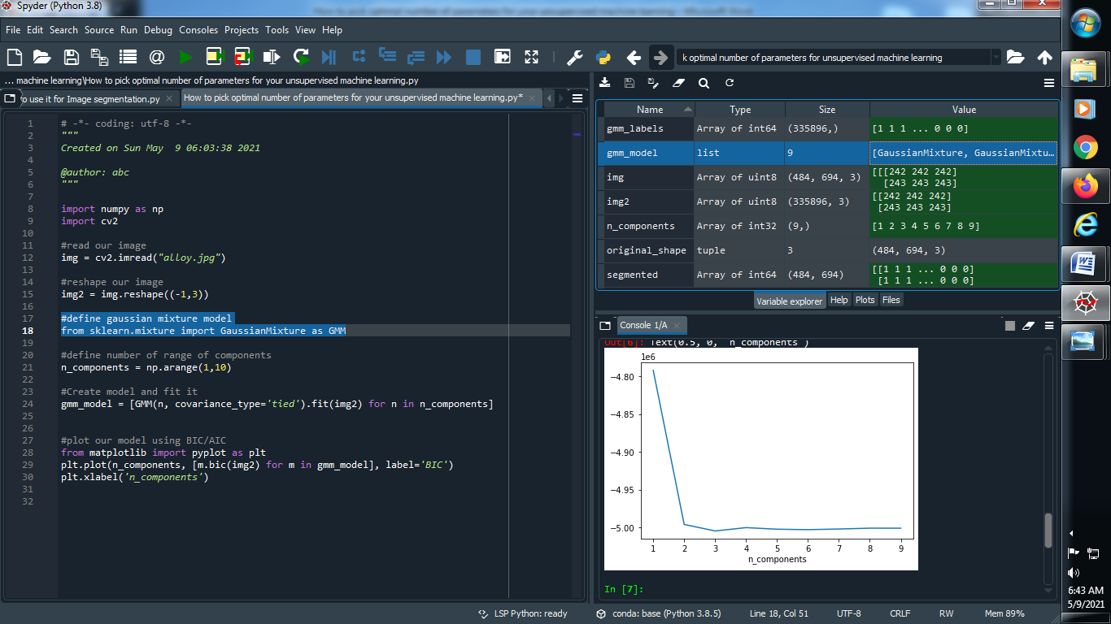

**Output :**



**(3) Define a range of number of components :**

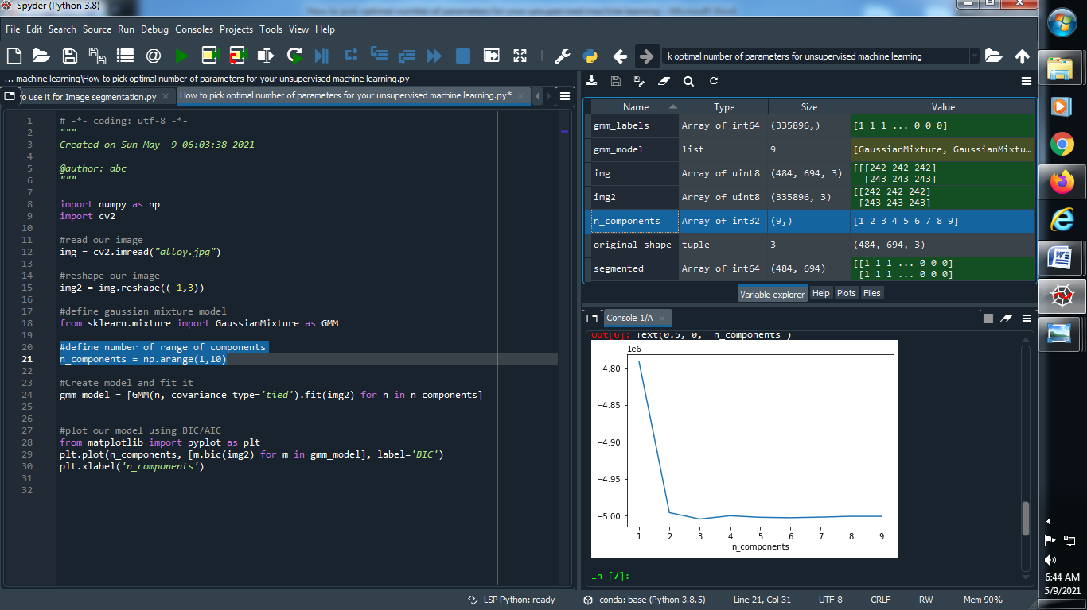

**Output :**



**(4) Create a model and fit it :**

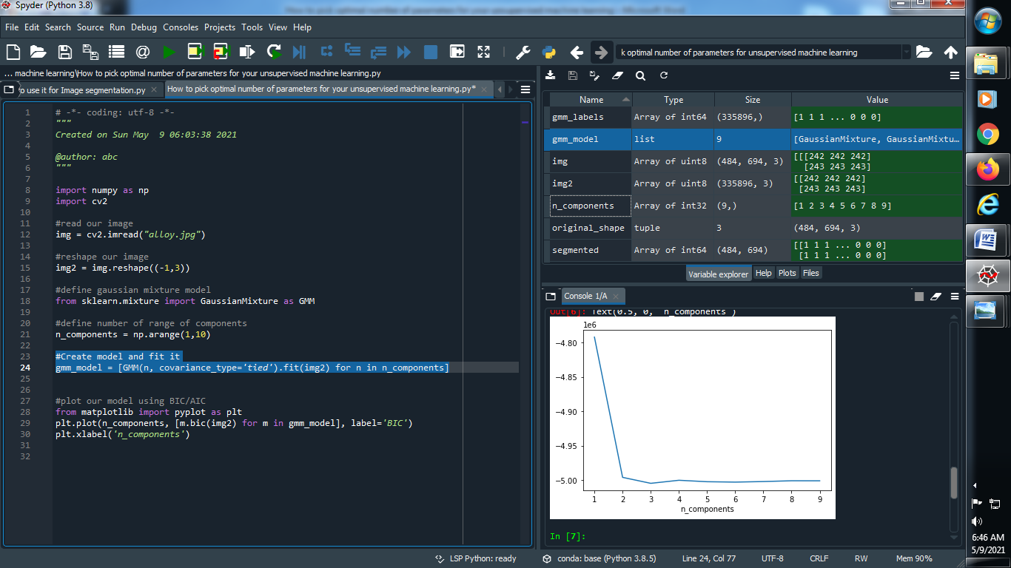

**Output :**



**(5) Plot our model using AIC/BIC :**

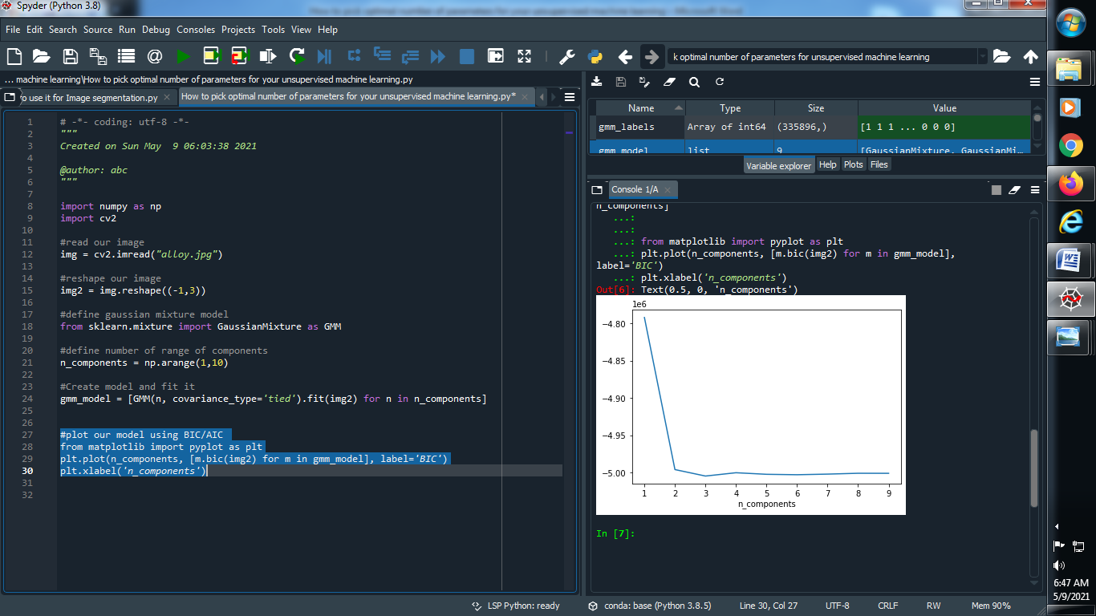

**Output :**

